**Summit/Raven Snow Science Protocol Summary:**

*Contact: Imogen Wadlow, eeiw@leeds.ac.uk*

*This document is intended to form an informal, brief overview of snow-pit sampling methods at Summit Station/Raven – this is adapted (blatantly copied) from the document ‘Raven Snow Science – ICECAPS-MELT 2024’ (Mike Town) with sections taken from ‘Snow, Weather and Avalanches, Chp 2: SnowPack Observations’ (American Avalanche Association (no publication date specified)) – this text is often referenced in literature as SWAG).*

**Motivation:** The snow science questions are centered around understanding heat transfer in snow to better predict when the snow in Greenland will melt. The data collection and monitoring are directed towards characterizing the snow stratigraphy to identify melt events and melt layers spatiotemporally. To support our understanding of this, models of heat transfer in snow need snow property data related to thermal conductivity and heat capacity. Some of the best proxies for the information needed for accurate modeling will be in the LWC, mechanical strength, and the density of the snow.

**Snow pit site:**

Planning the location: At Summit, a snowpit was dug near the (T)AWO between the Clean Air Sector flag line and the Clean Campaign Flag Line. The surrounding snow should be undisturbed, and should not be located near a previous snow pit site (see ‘Summit 2024 Snow Pit Summary for details on this – available at the Snow Science Github Repository: https://github.com/icecaps-summit/snow-science/tree/main/20240718_Summit_SnowPit).

Digging the snow pit: Identify your location by staking your snow-pit science wall – this is easy to do with ski or bamboo poles. It is important to communicate to your team not to step on the snow surface beyond those poles (succinctly phrased by Mike Town as *“Don’t step on the science”*). You’ll make a decision on which orientation your snowpit face will be – ideally you’ll want this to be shaded from the sun and not having wind-blown snow deposited on the surface. At Summit, we were sampling a North-Facing snowpit wall.

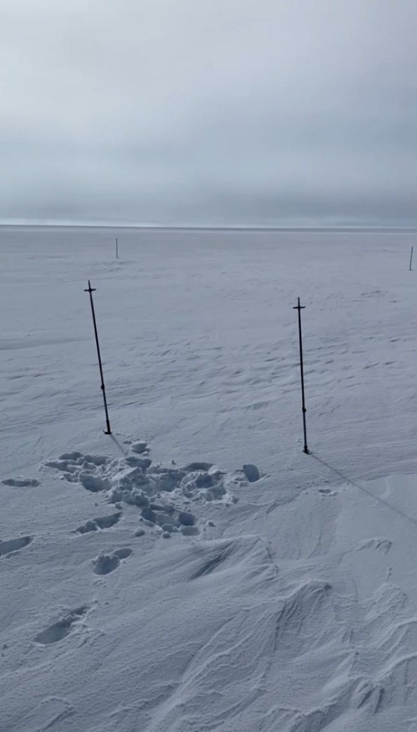

Figure 1: Staking the North-facing wall at Summit (don’t step beyond these poles!).

In consolidated snow, it is strongly recommended to cut out the snow in blocks with the snow saws. This saves time, energy, and mitigates risk of injury while digging. If you are organized (which is not always possible), you can more or less replace the blocks from where they came. Even if you don't, by using this method, you greatly reduce the compaction and sintering that comes from shovelling snow here then there.

You’ll want to create some steps while you’re digging on the opposite snow pit wall to help your team get in and out of the pit– we also dug some shelves into the unused walls of the Snow Pit for science gear that needed to be stable (e.g: weight scales).

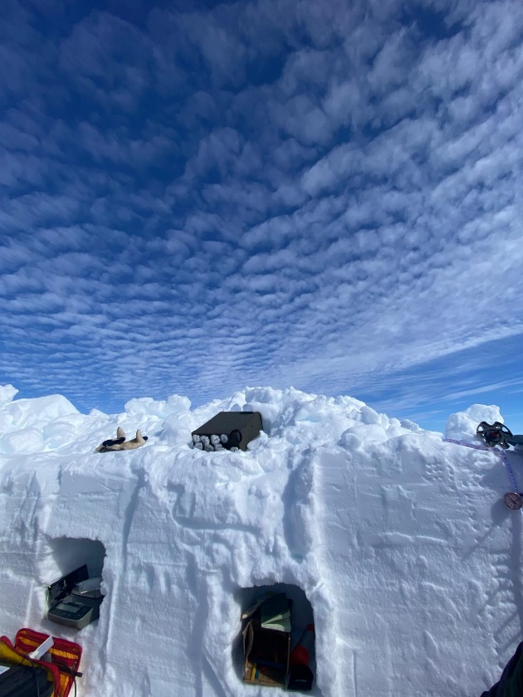

Figure 2: Shelves in the Summit 2024 snow pit

Advice for digging – taken from ‘Snow, Weather and Avalanches, Chp 2: SnowPack Observations’:

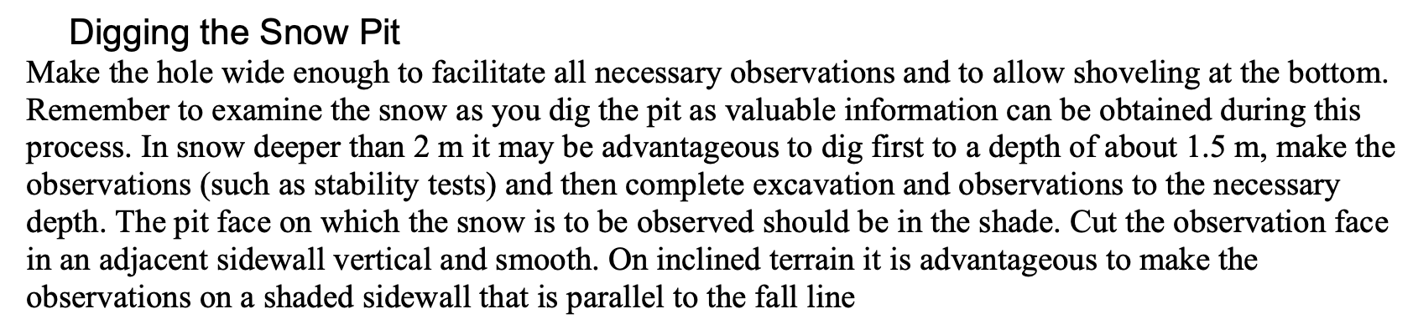

Note: Take pictures of everything if you can. In particular, it’s important to take pictures of context and process. This saves writing, but the pictures must be saved in appropriate places. If important information is contained in a photo/video, that still needs to be noted somewhere.

**Documenting the snow pit site:**

This information should include:

* Location (GPS coordinates)
* Orientation of measurement face (e.g: *prevailing wind westerly 🡪 cutting face on west side)*
* Weather conditions – ambient temperature, wind, cloud cover

*Example:*

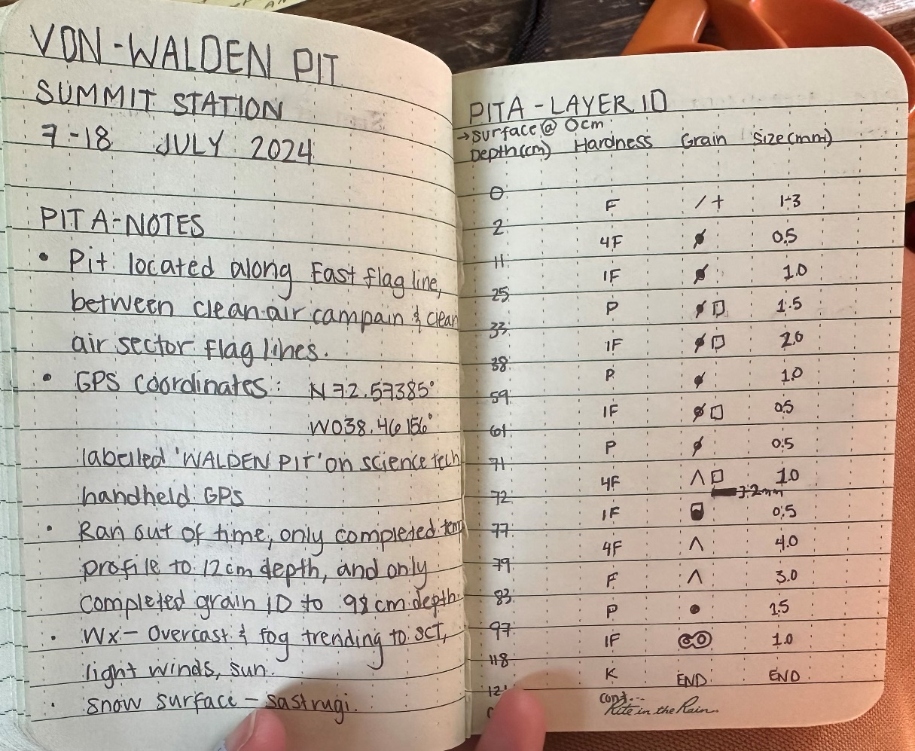

Figure 3: Field notebook describing location and environmental conditions at the Summit snow pit site.

**Measurements:**

Summary of measurements completed at Summit/Raven 2024:

|  |  |  |
| --- | --- | --- |
|  | *Measurement* | *Reference* |
| 1 | Snow Temperature | SWAG Chp2 |
| 2 | Snow density / Liquid Water Content / Specific Surface Area (SSA) | SWAG Chp 2 Section 2.2 for LWC (manual), SLF SnowPro User for density/LWC/SSA) |
| 3 | Isotope Sampling |  |
| 4 | Layer ID | SWAG Chp2 |
| 5 | Hand hardness | SWAG Chp2 |
| 6 | Snow crystal size / habit ID | SWAG Chp2 |
| 7 | Lyte Probe measurements | Instrument manual |

**Tools/Gear:** This is a list of snow science sampling gear used at Summit Station/Raven campaigns 2024.

|  |  |
| --- | --- |
| **Snow Science Packing List** | |
| **Lyte Probe:** | |
| Lyte Probe 2 | MS Surface charger |
| Two (2) lyte probe wall-chargers | MS Surface external keyboard |
| Two (2) white 3-m USB-mini/USB-A data cables | USB splitter/GPS |
| MS Surface data acquisition computer with field operation sling | Aquaquest water-proof laptop case (**black**) |
|  |  |
| **Snow Science (Pink HH bag)** | |
| ESR Snow Science/Lyte Probe field notebook | Dry wall saw |
| Pencils/pencil sharpener/Sharpie/AAA batteries/ | 2 x Bar clamp |
| Four (4) snow saws | 500 WhirlPak bags |
| Four (4) snow science kits (temperature, snow cards, snow meter stick, magnifying loupe, brush, popsicle sticks, clineometer, compass) | Umbrella |
| 100 cm2 shear frame | Wind-up measuring tape |
| 250 cm2 shear frame | Pencil sharpener |
| Two (2) Emergency shelters | Fluro tape (non-sticky) |
| Two (2) snow density volumes | Thumb tacks in falcon tube |
| One (2) fish hook scales (max reading) | Two (2) Snow grain gridded plates (Brooks-Range Mountaineering) |
| Two (2) 5-Newton spring scales | Neewer microscope lens (attaches to your phone) |
| Two (2) digital mass scales. | 1 pair gloves |
| Wire cutters/precision screw driver/**USB data drives** | Zip-lock bag of plastic Q-tip looking connectors? |
| Bamboo skewers (100) | Metal wedge & plate |
| Rainbow popsicle sticks (200) | Two (2) foldable rulers |
| Laser Level |  |
|  |  |
| **Black pelican case - LWC Density (FPGA Company)** | |
| LWC density instrument | 2 x USB to 5-prong male to male cable |
| F4040 large plate | 2 x InfraSnow plates (one larger, one smaller) |
| F17 small plate | Infrasnow instrument (for SSA) |
| 2 x USB to 5-prong male cable |  |
|  |  |
| **Black pelican case – manual density sampler.** | |
| Electronic scales | 2 x metal volume samplers (one large, one small) |
| 2 x metal tubes | brush |
| 2 x palette spatulas (one straight, one bent) | grid printed plate - grain size ID |
| 2 x 9V batteries |  |

**Measurement techniques:**

**Snow temperature:**

* *For Summit campaign: The snow temp probes are located in the yellow/red ‘Snow Science bags’ in the HH bag*

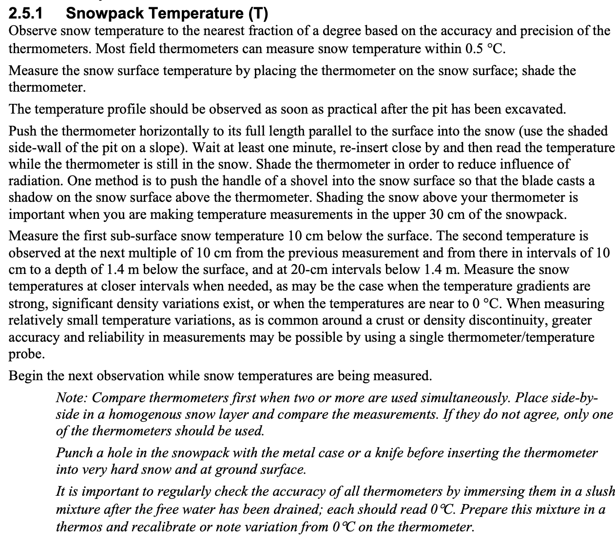



*Notes:*

* Temperature measurements should be taken **first**, to prevent impacts of solar bias. Take measurements quickly after exposing snow pit face, or dig deep into pit face, ~30 cm/day the face has been exposed.
* Try to shade the sensors as much as possible (using an umbrella or other).
* Temperature measurements are to be taken at the same increment as your density samplers – at Summit, this was at a spacing of 3cm. In Chp2 of SWAG, this is specified as 10cm increments to 1.4m, and then 20cm intervals below 1.4m.

**Snow density/Liquid Water:**

There are two methods of taking snow density – one is with a manual sampler, and the other is using the FPGA Infrasnow instruments (SLF Snow Sensor). Screenshots in this section have been taken from the FPGA Infrasnow instrument manuals.

SLF Snow Sensor:

* For Summit: Snow density instrument (SLF) has its own Pelican case, SLF SnowPro (FPGA Company):

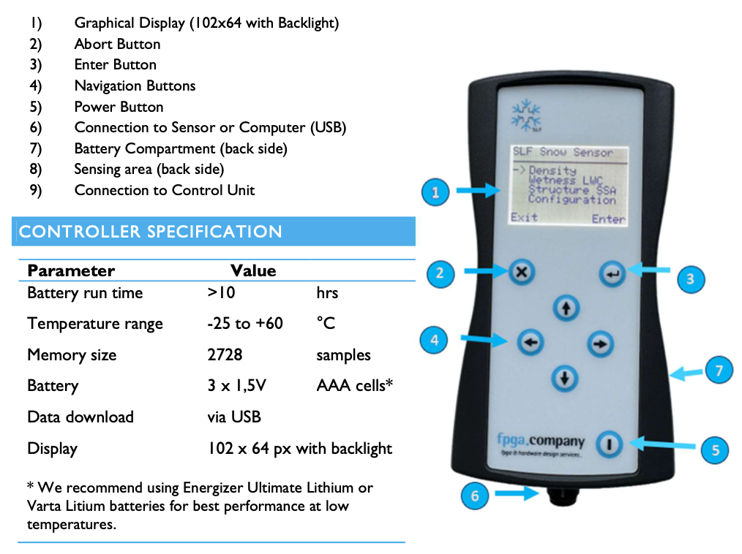

The SLF instrument measures the density or Liquid Water Content of snow with a capacitive sensor, which generates an electrical field permeating the snow. Measured capacitance changes as ice, air and water have different dielectric properties.

***If the snow is dry*** *🡪*  snow density can be measured directly

***If snow has some water in***🡪 these tools measure LWC.

***To measure LWC***🡪 the ice fraction (dry snow density) must be known (so we need to calculate density manually).

There are two sensors associated with this instrument, the *dens17* and *dens4040.* The *17* is applied on top of the snow, and the *4040* is inserted vertically into the snow for profile measurements. These are plugged into the cable attached to the SLF body with the screen. **Clamps are provided as part of the kit to hold these sensors** – if you hold these with your hands, heat/moisture transfer may impact measurements.

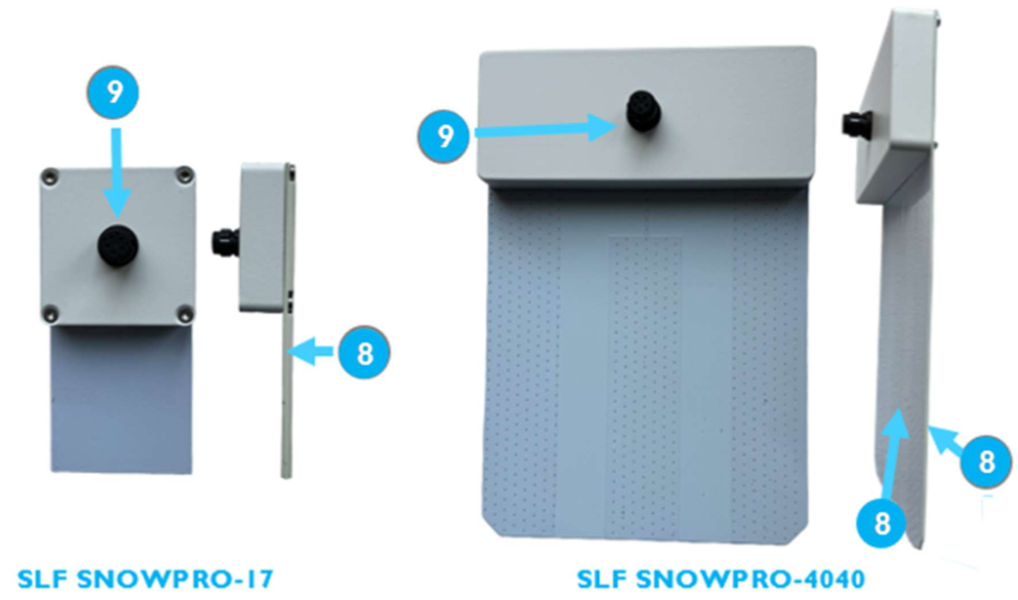

**Sampling methodology:**

To measure snow density (for dry snow with no liquid water): (taken from Raven doc):

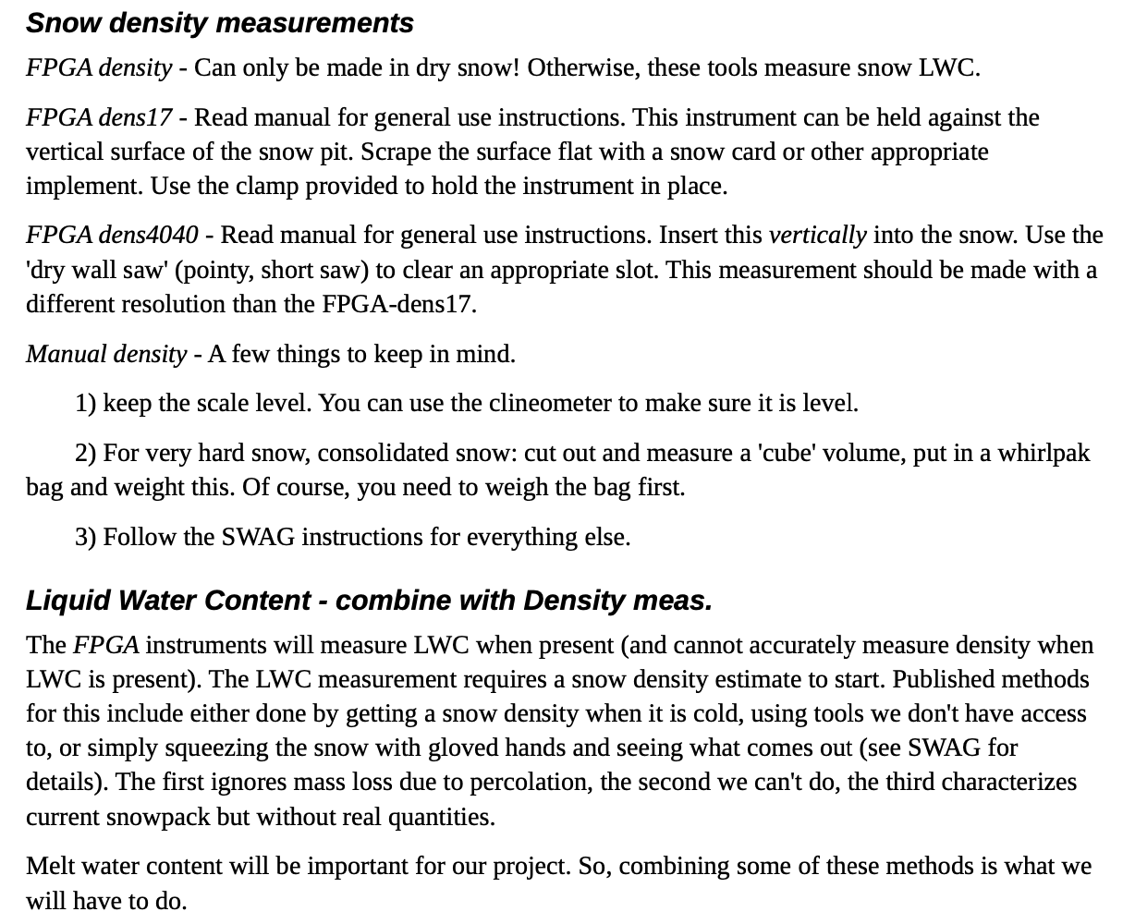

At Summit, we installed measuring sticks (pinned in place with temperature probes) for the manual and SLF density sampling. I used different colours of marker pens to mark the increments for the SLF-17 and -4040 on the measuring stick which was helpful in the field. **The increments are the width of each sensor – so measurements are taken every 4.5cm for the -17 sensor (placed on top of the snow surface down the wall), and every 11.5cm for the -4040 sensor (inserted vertically into the snow pit face)** (See Figure 4 for reference).

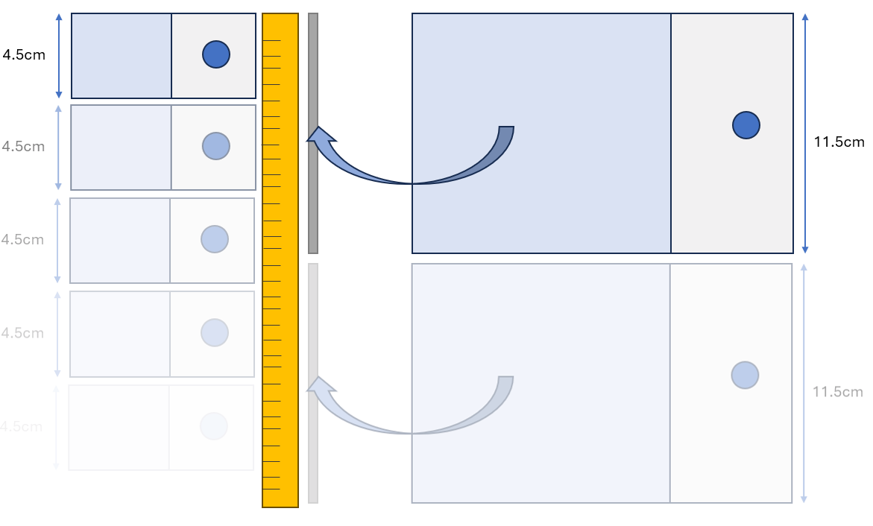

Figure 4: SLF -17 and -4040 sensor sampling diagram. The yellow bar indicates the measuring stick.

The following instructions for sampling methodology are taken from the SLF instrument manual:

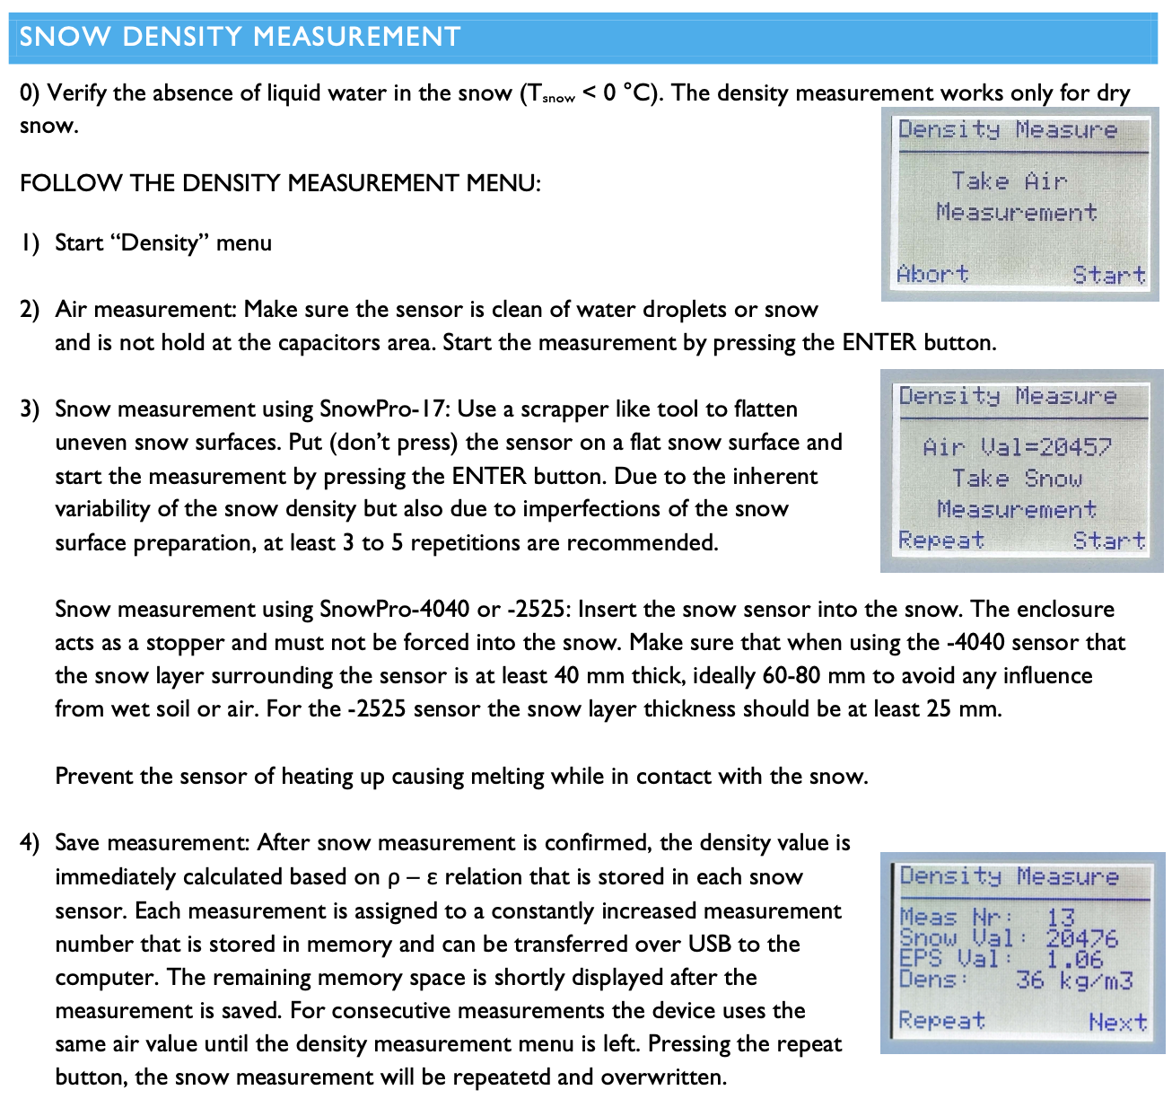

For each SLF density measurement, you need to mark down the depth and the sample ID for the -17 and -4040 measurements – see Figure 5 as an example from a field notebook.

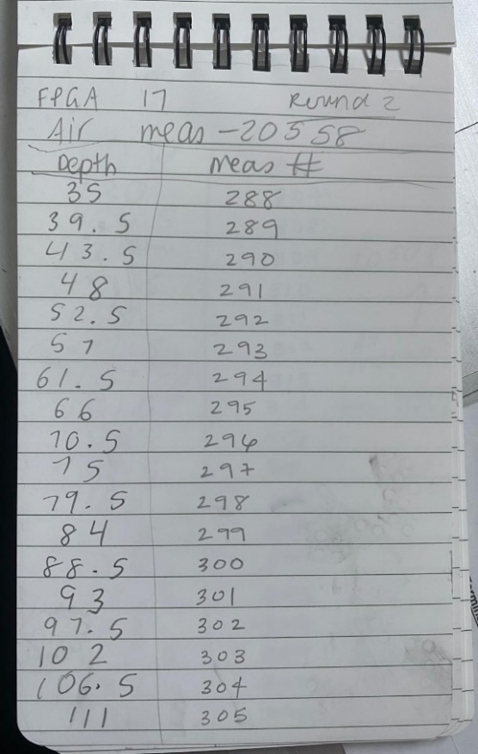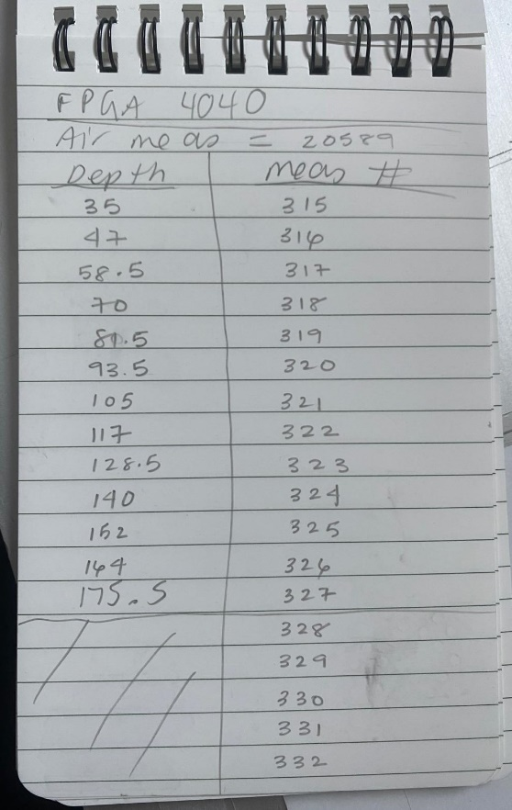

Figure 5: Example of field notes for the -17 and -4040 sensors – showing the depth (noted as the top of the sensor) and the corresponding measurement ID (shown on the screen of the SLF instrument).

**Manual density measurements: (Also required to measure snow Liquid Water Content in the SLF sensor):**

These measurements are required to measure snow Liquid Water Content in the SLF sensor. The tool comprises a metal cutter and a lid. At Summit & Raven, we used the box cutter (100cm-3).

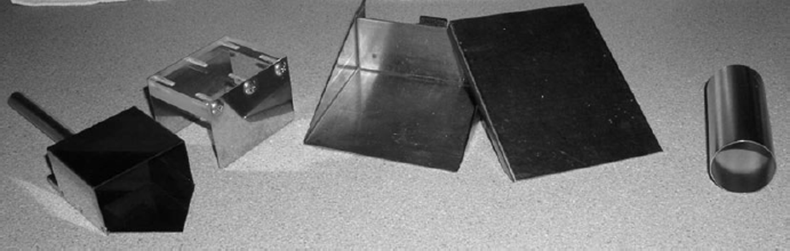

Figure 6: Manual snow density cutters – image from Conger, et. al. 2009: Left to right: box (Hydro-Tech 100 cm3), wedge (Snow Research Associates 200 cm3) and tube (Wasatch Touring 100 cm3).

To take a manual density measurement, there are a couple of methods. This is a method if there is no liquid water inside your column (as we experienced at Summit):

1. Weigh the empty cutter + lid (using your measuring scales – we put these inside one of the shelves cut in the snow pit wall for stability and to shield the plate from the sun).
2. Starting from the top surface of the snow wall, note the starting depth on your measuring stick (e.g: because of how we installed the measuring stick, our surface measurement started at 35cm).
3. Insert the cutter into the snow, then while the cutter is in the snow wall, push the lid on to trap all snow inside the sampled column (i.e: don’t remove the cutter from the wall, then put the lid on).
4. Remove the cutter + lid from the snow wall – it helps to shake the cutter from side to side to remove any bits of snow on the outside.
5. Use a brush/scraper to remove any outside snow on the cutter.
6. Weigh the cutter + lid again with the snow inside.
7. Before you take the next measurement, use a brush/scraper to remove any snow grains from the cutter.

Note, at Summit – instead of weighing the cutter, we emptied the cutter contents into a Whirlpak bag (for future isotope analysis) and weighed the empty bag and bag + snow contents. This was done due to time restrictions.

For snow with liquid water content, the procedure to follow is (following similar cutter sampling steps as outlined above):

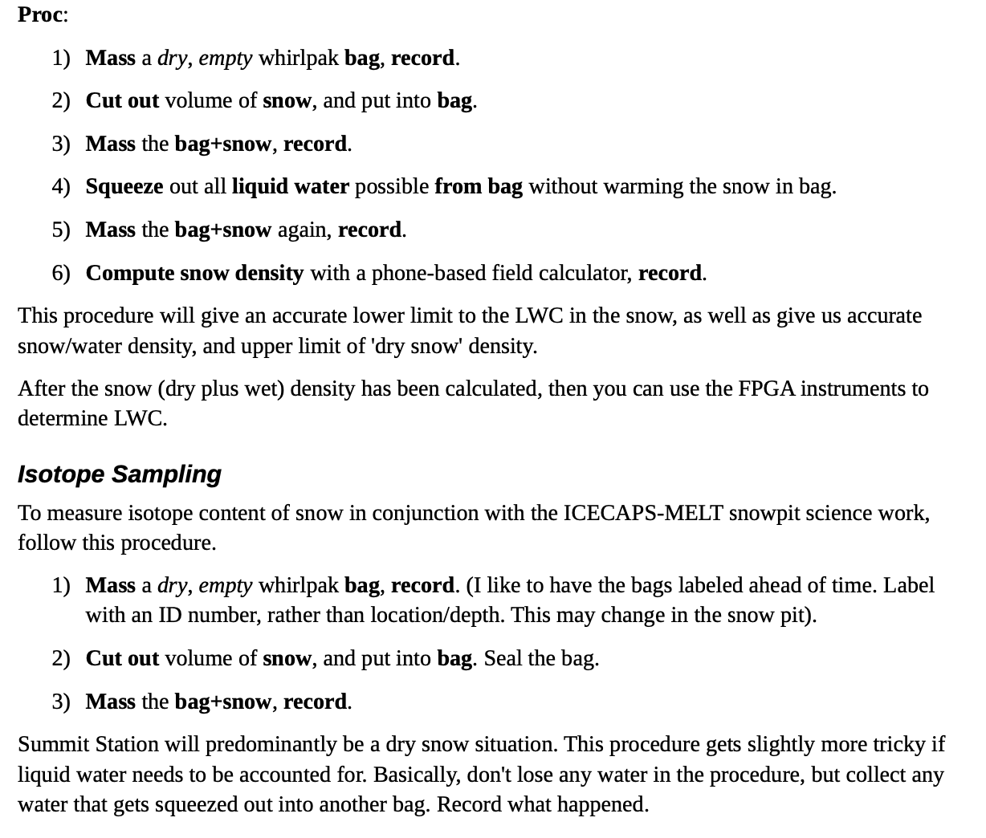

When inserting the cutter into the snow pit wall, we followed a staggered sampling approach and created two sampling columns next to each other. This allows you to make more clean cuts without worrying about channel collapse influencing neighbouring measurements (see Figure 4 and Figure 7 for reference).

**

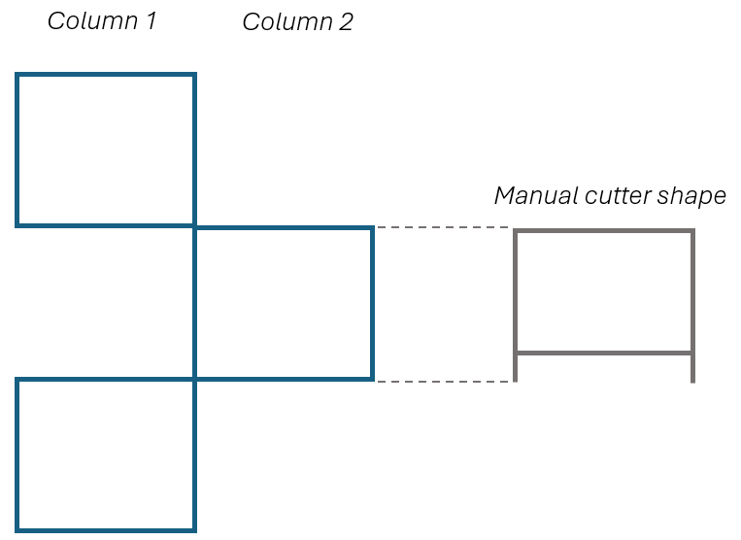

Figure 7: Figure 4: Diagram of manual density sampling technique. The first sample is taken from Column 1, then alternating between columns, aligning the top of the manual cutter with the base of the previous measurement (and measuring stick pinned into place with temperature sensors).

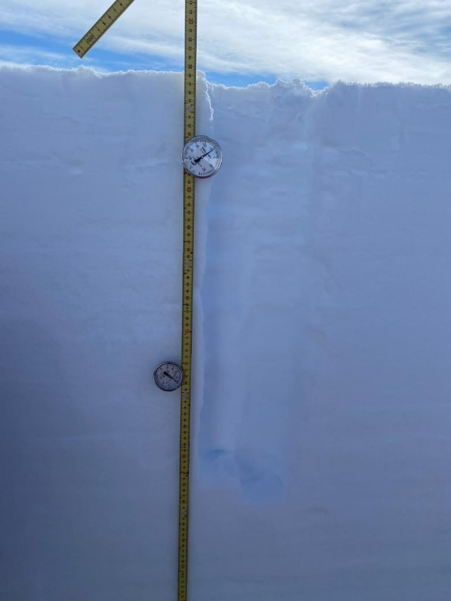

Figure 8: Manual density & SLF sampling site – SLF measurements were taken on the left of the measuring stick in this image. Manual density measurements were taken on the right of the measuring stick – two columns of cutter samples are seen.

*Notes from the Raven doc:*

**Measuring snow density with Liquid Water content using the SLF sensors:**

The following instructions have been taken from the FPGA instrument manual:

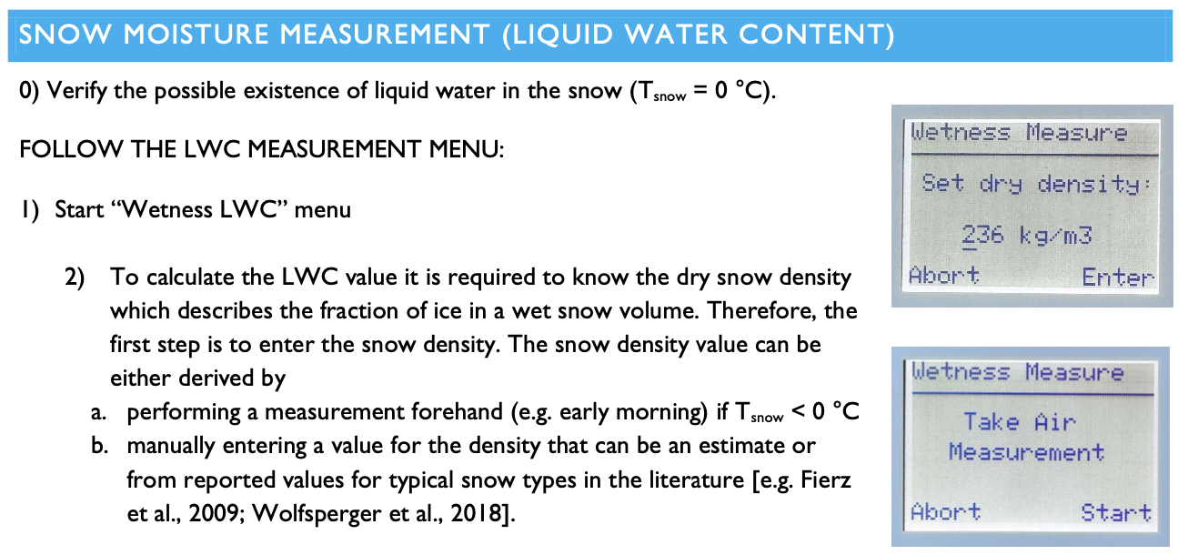

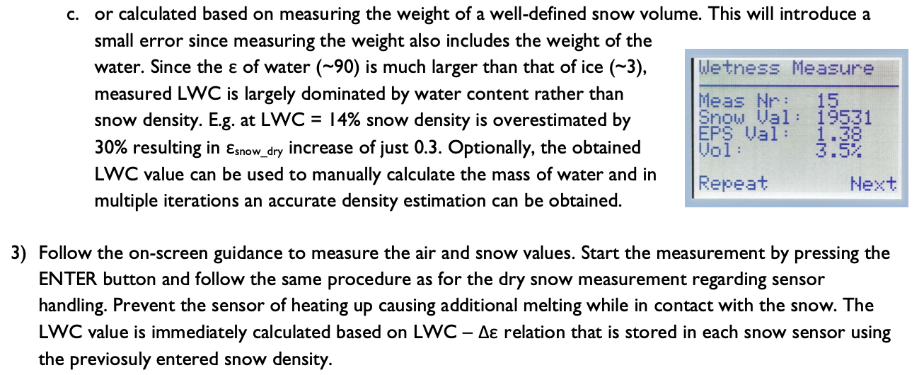

*Other notes from the manual: to see/set time on the instrument: (it’s a good idea to keep measurements in UTC where possible).* 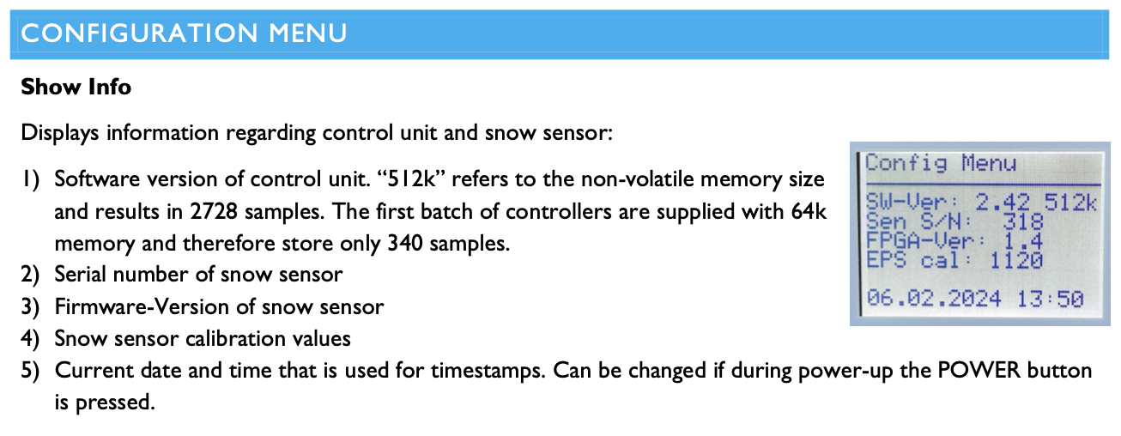

**Specific Surface Area (SSA) measurements:** The FPGA SLF Snow Sensor also has an optical Specific Surface Area sensor – instructions are available on the instrument manual (we didn’t get around to completing these measurements at Summit).

**Isotope sampling:** This is something that will be completed at Summit.

**

**Layer ID:**

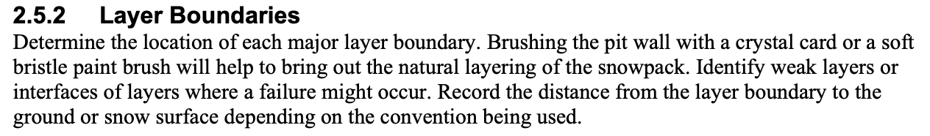

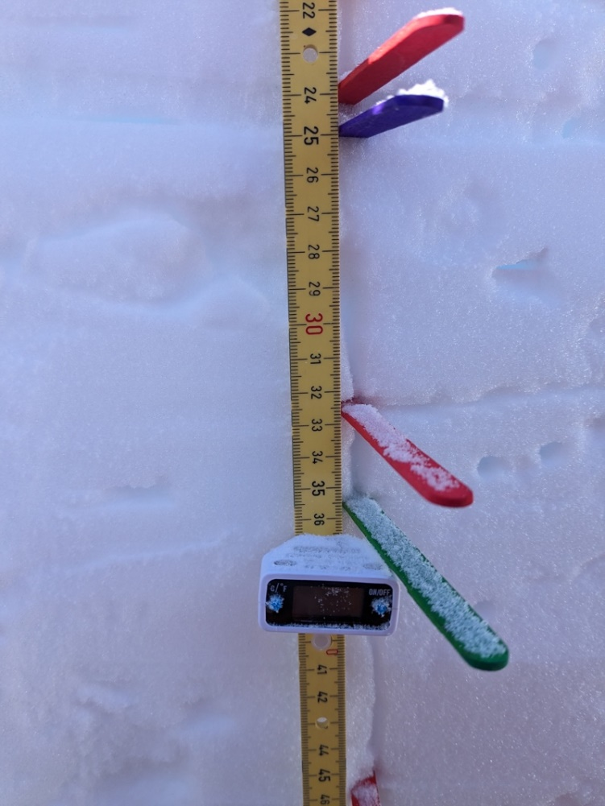

Figure 9: Marked snow layers at Raven with temperature probe (Image: Andrew Martin)

*Layer ID* - identify summer layers, crusts, and other holistic changes in material properties.

Profile resolution - try to get up to 3-cm resolution in all things. Of course, the layer ID will help you identify when that is appropriate, and when it is unnecessary. Layer ID will have higher precision than anything else (~ 1cm or less).

*Profile sampling protocols* - try to sample above and below crusts/hoar/and other thin layers with things like HH, snow density, shear strength. Try to sample thin layers separately whenever possible (e.g. snow grain size, snow grain type).

**Hand Hardness**

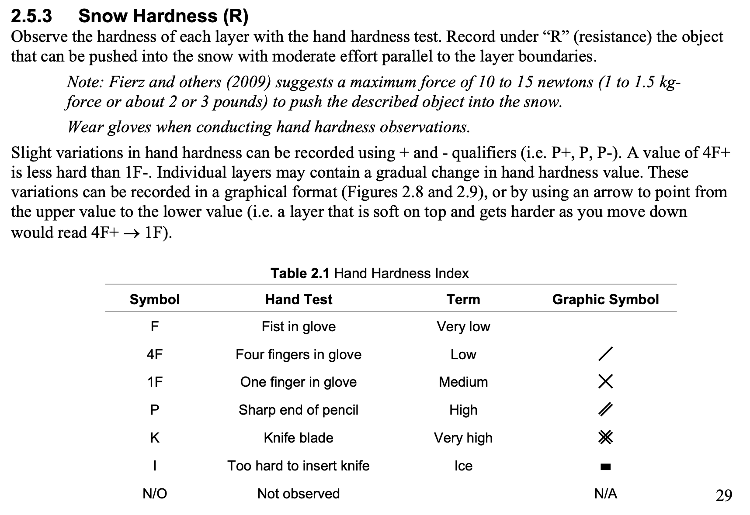

**Snow crystal size/habit ID** 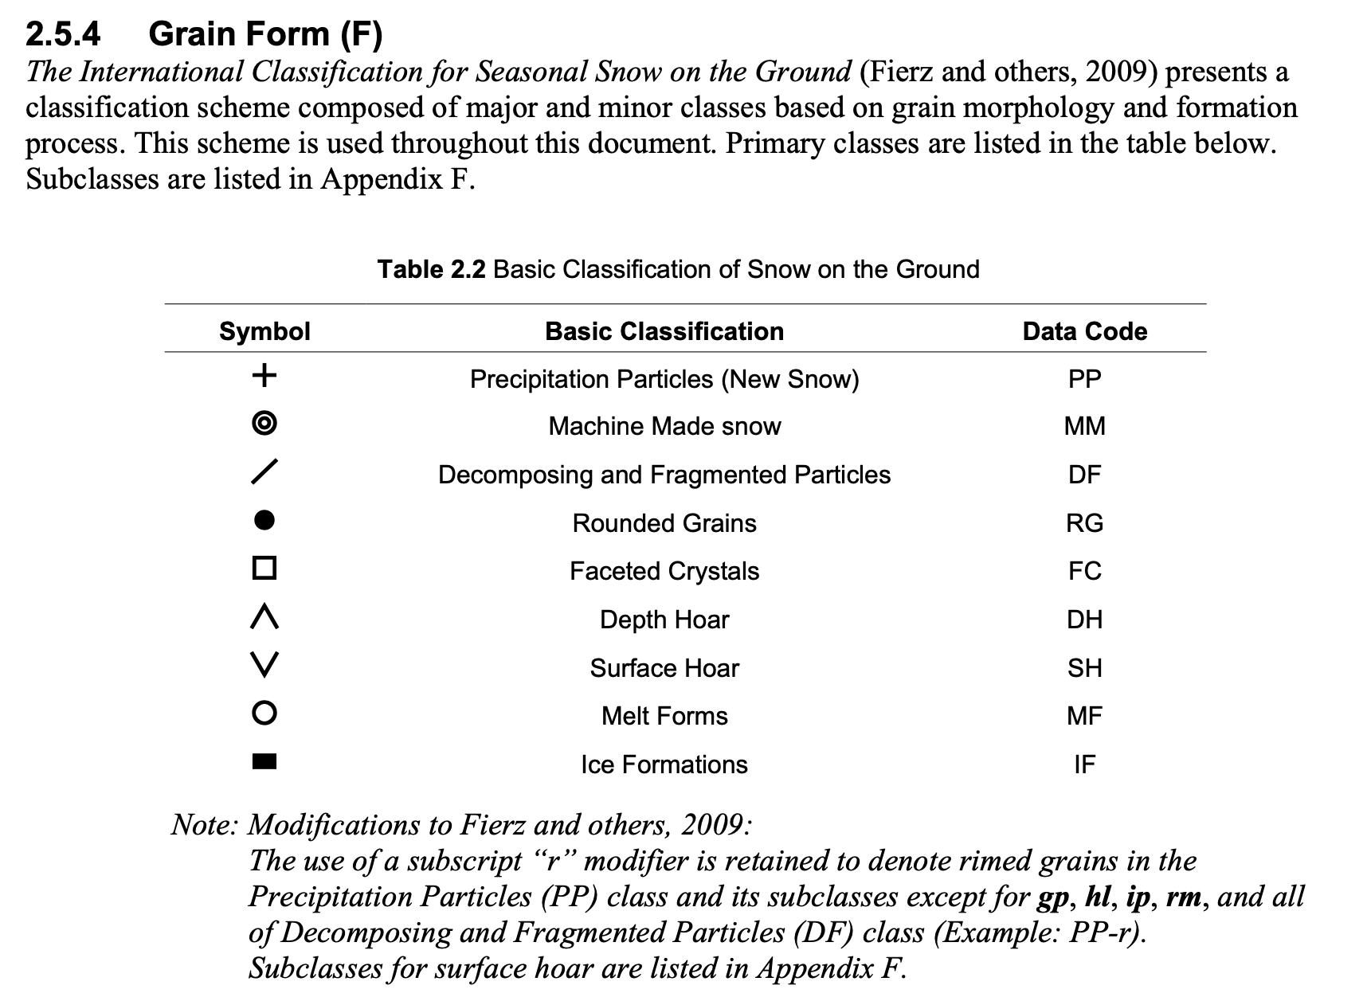

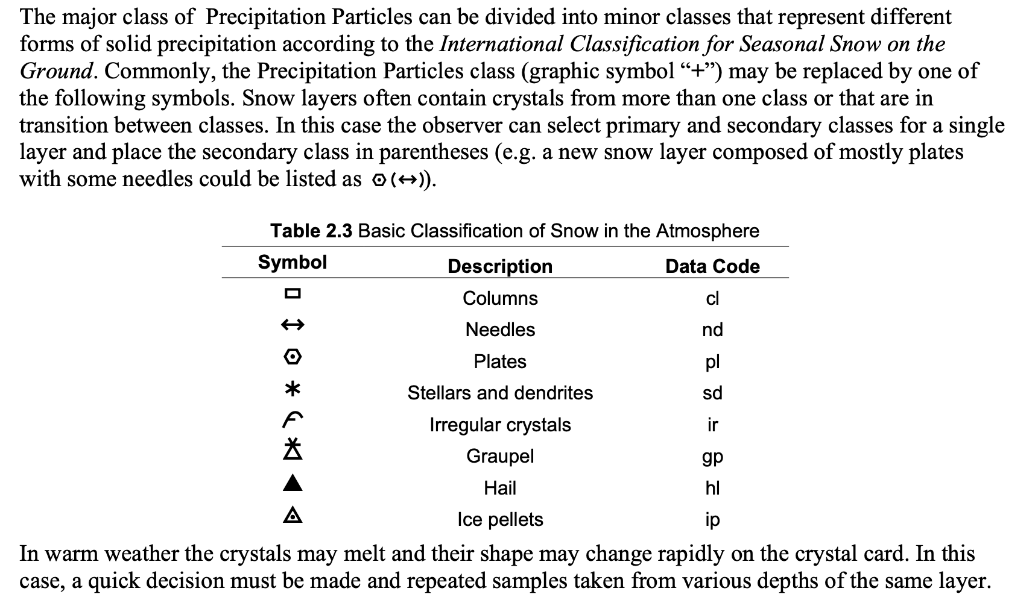

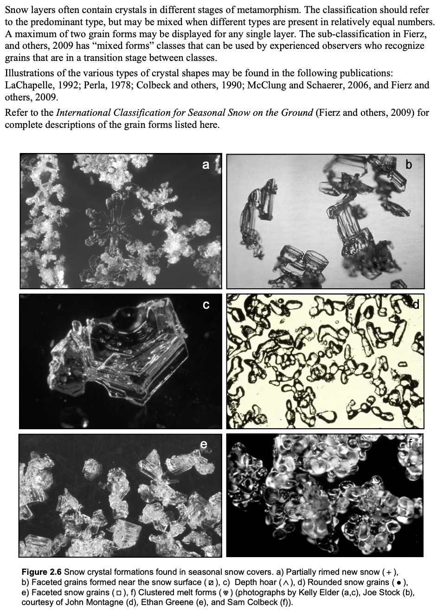

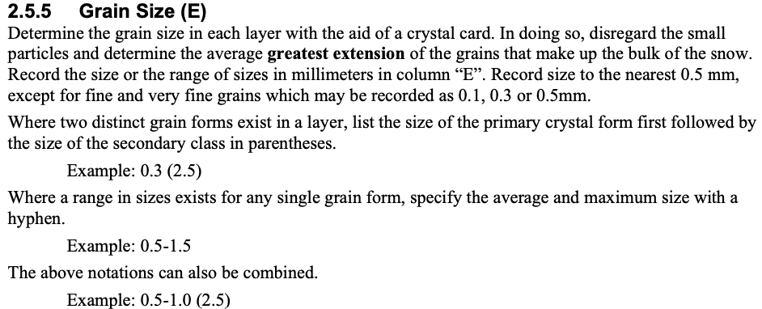

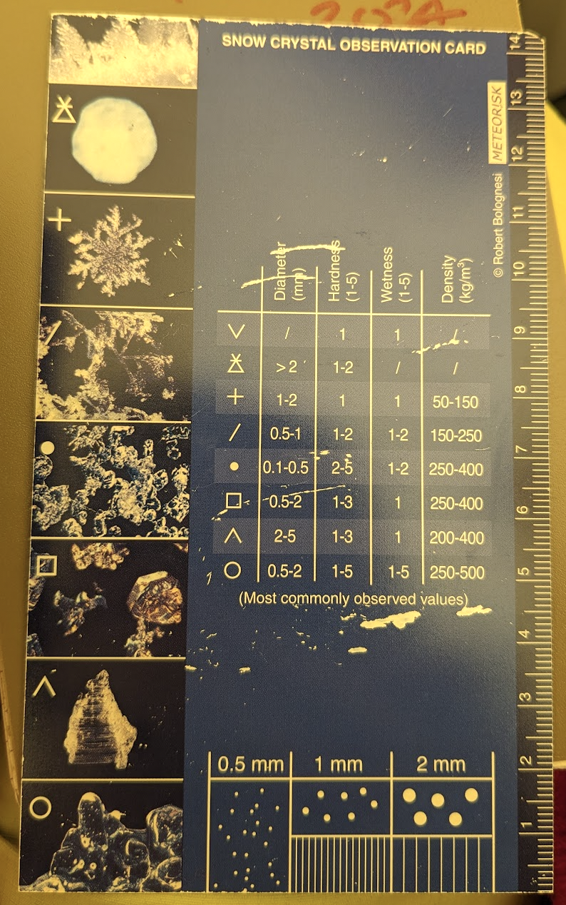

Figure 10: Snow Crystal ID card, Image: Andrew Martin

**Measurement notetaking:**

Measuring depth: Record the reading on the meter stick. Do not do math in the field. The dramatic exception to this is measuring LWC with the FPGA instruments. In this case, we need a density measurement before measuring LWC.

Below are lists of measurements to make broken down by field operation task. Included in each table is a list of measurements for 'calibration' or 'uncertainty' of specific tools/measurements. The lists are in checklist form for use in the field. Record all field data in green Rite in the Rain notebook.

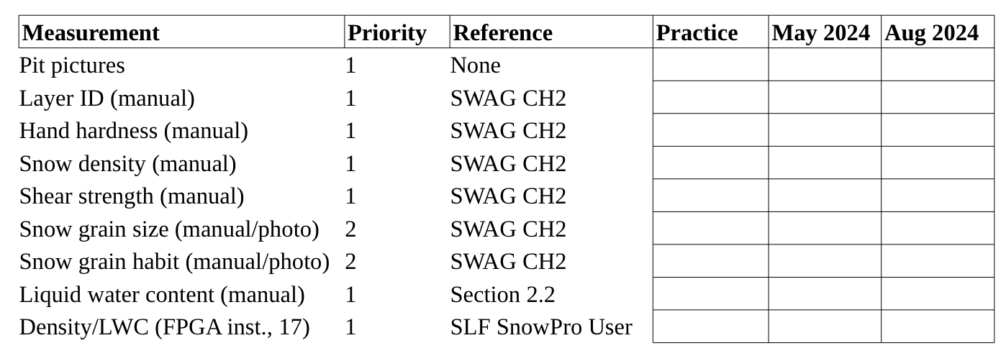

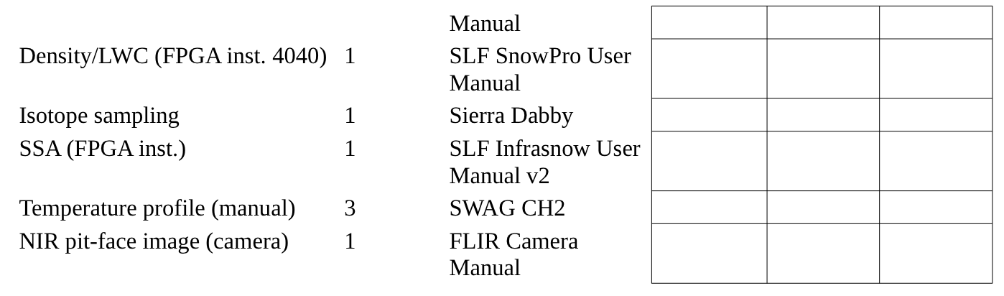

*Table 1. A list of measurements and calibration tasks for the snow pit (from Raven). The right-hand side of the table is a field checklist.*

*Field notes example:*

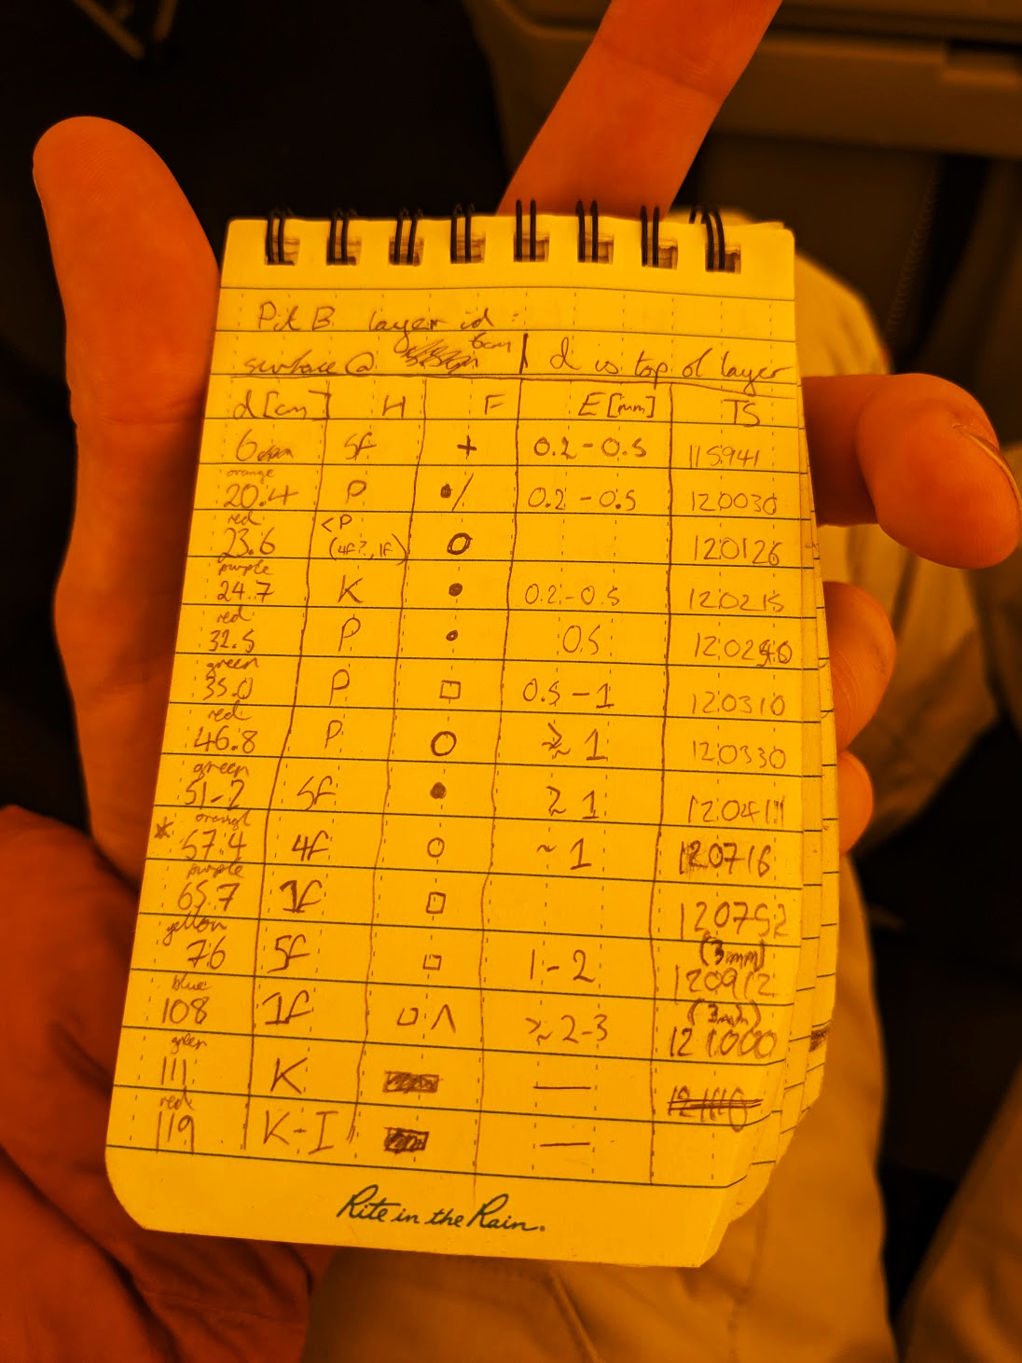

Figure 11: Snow Layer ID note-taking. Picture: Andrew Martin (Raven)

**Lyte Probe Measurements:**

*Lyte probe measurement procedure* (and important metadata) are described in Lyte probe doc.

Most Lyte Probe usage is described in the manual. Some important things to note when using the Lyte Probe in hard snow/ice (now redundant with what is in the manual).

1) When going through hard surfaces, it is better to use 'constant' pressure rather than quick, blunt force. The main thing is to avoid high accelerations (> 14 gs).

2) When using large amounts of force, please keep hands and body away from the data cable connections.

3) Probe 1 has a high force range (0-30 N), whereas Probe 2 has a small force range (0-15 N). So, you can choose which one to use if you are interested in characterizing hard or soft snow.

4) When making horizontal probe strikes, you may encounter an error to do with surface detection (type 0). Don't worry, data has still been collected. If you encounter a 'comms' error, then the data cable has become unseated.

5) If something funny comes up, take a screenshot of the error on tablet screen.

**Lyte Probe Adjacent to Snow Pits**

Table 2. Lyte probe measurements that ought to be made adjacent to the snow pits shown in Figure 2 are list below. Check list here in case it is helpful in the field.

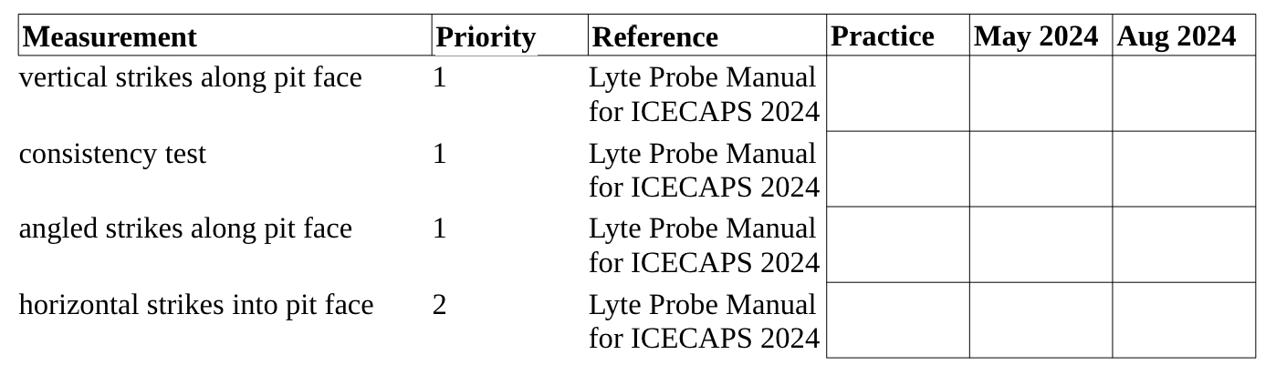

NOTE:

*When to measure -* Try to make these LP measurements within a day or two of digging the snow pit. Ideally you are probing the area first to make sure that an intercomparison with snow pit data is even viable. Try to make the LP measurements on the upwind side of the snow pit after the pits have been sampled.

*Consistency test* - In this box, keep strikes around 5 cm apart. Suggest to record the pattern (if possible) after completion (a small circle or square). Be careful to make strikes vertical. Use clineometer to check angle of attack in situ to self-calibrate on angle of attack. An angle of 3 deg should correspond to about 5 cm deviation from vertical over 1 m.

**References:**

American Avalanche Association. (unsure of publication date). Chapter 2: Snowpack Observations. *Snow, Weather and Avalanches: Observation Guidelines for Avalanche Programs in the United States*.

Conger SM, McClung DM. Comparison of density cutters for snow profile observations. Journal of Glaciology. 2009;55(189):163-169. doi:10.3189/002214309788609038